US Army Training and Doctrine Command

Lesson Plan for Tier Three: Soldiers and Units
Army Policy on Military Service of Transgender Soldiers

1. SCOPE
On 30 June 2016 Secretary of Defense Ash Carter announced that “[o]therwise qualified Service members can no longer be involuntarily separated, discharged or denied reenlistment or continuation of service just for being transgender.” DoD Directive-type Memorandum (DTM) 16-005, DoD Instruction 1300.28 (In-Service Transition from Transgender Service Members) and Army Directive 2016-35 (Army Policy on Military Service of Transgender Soldiers) establish policies and procedures for gender transition while serving in military.
DoD and Army leadership recognize that transgender people already serve in uniform. This policy serves to meet the Army’s responsibility in providing clear and consistent guidance to commanders, core professionals, Soldiers, and Soldiers pursuing officially recognized gender transition.
HQDA identified TRADOC as one of several commands supporting the effort of educating the force on the policy shift regarding the military service of transgender Soldiers.
This lesson will assist Soldiers in understanding Army policy for the Military Service of transgender Soldiers so that they can implement the policy while maintaining morale, readiness, and good order and discipline train subordinate Soldiers on the policy; and assist Soldiers who have a medical diagnosis indicating that gender transition is medically necessary through the gender transition process.

2. TERMINAL LEARNING OBJECTIVE (TLO): Apply the Army’s Transgender Integration policies and procedures to maintain good order, discipline, and unit readiness.
Action: Inform Soldiers on Army transgender policy, the gender transition process, and commander, medical, and transitioning Soldier responsibilities.
Condition: Through classroom instruction and drawing on past training, education, personal experience, and individual learning from the operational environment.
Standard: Informing will include a discussion of:
- Transgender Policy
- Gender Transition Process
- Prohibition on Harassment and Discrimination
- Terminology
- Transitioning Soldier Responsibilities
- Commander Responsibilities
- Military Medical Provider Responsibilities
- Vignettes

3. ENABLING LEARNING OBJECTIVES
- Soldiers understand the overarching DoD and Army policies on transgender service.
- Soldiers maintain good order and discipline.
- Soldiers understand basic process on how to initiate gender transition, if necessary.
- Soldiers understand terminology associated with gender transition in the Army.
Standard: Informing will include a discussion of:
- Understanding of Army and DoD Transgender Policy
- Understanding the gender transition process in relation to Army service
- Understand transitioning (gender) Soldier responsibilities
- Understand and apply Soldier responsibilities
Learning Domain: Cognitive
Level of Learning: Application

4. ASSIGNED STUDENT READINGS: NA
5. INSTRUCTOR ADDITIONAL READING/MATERIAL: NA
6. TRAINING AIDS, REFERENCES, AND RESOURCES:
7. CONDUCT OF LESSON

- Lesson Timeline:

10 minutes Policy Changes
10 minutes The Transition Process
10 minutes Soldier and Commander Responsibilities
30 minutes Discussion/Vignettes

 | 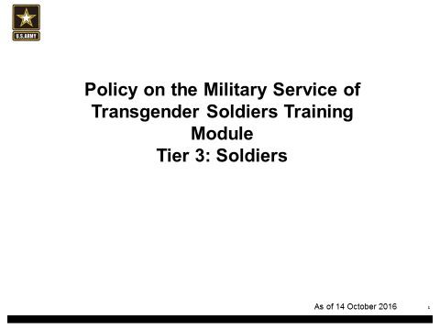
 | 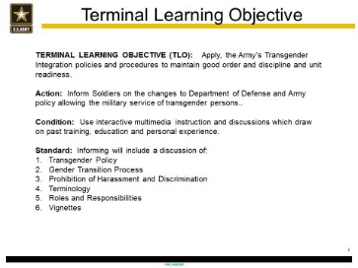
Introduction:  Secretary of Defense Ash Carter announced the new Department of Defense policy on 30 June 2016 | 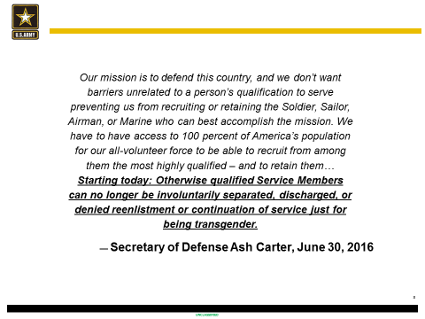
ELO: Soldier understands Army policy on transgender military service has changed. | 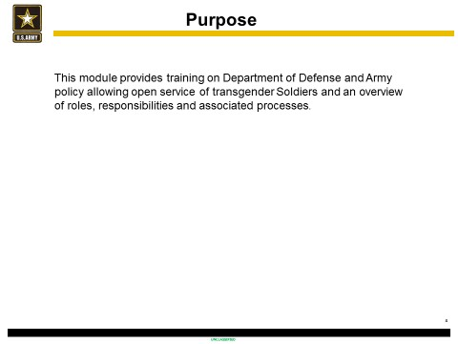

In July 2015, the Secretary of Defense directed the Department of Defense to identify the practical issues related to transgender Americans serving openly in the military and to develop an implementation plan that addresses those issues consistent with military readiness. On June 30, 2016, the Secretary announced a new policy allowing open service of transgender Service members and outlined three reasons for this policy change:

- The Army, Navy, Air Force, Marine Corps, and Coast Guard need to avail themselves of all available talent in order to remain the finest fighting force the world has ever known. The mission to defend this country requires that the Services do not have barriers unrelated to a person’s qualification to serve or preventing the Department of Defense (DoD) from recruiting or retaining Service members.
- There are transgender Service members in uniform today. DoD has a responsibility to them and their commanders to provide clearer and more consistent guidance.
- Individuals who want to serve and can meet the Department’s standards should be afforded the opportunity to compete to do so.

ELO: Soldiers understand the U.S. Army policy on transgender military service has changed. | 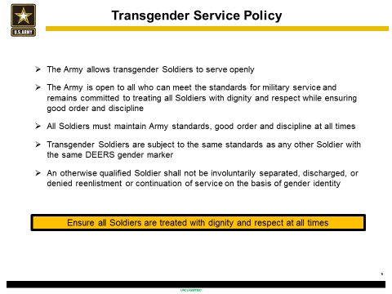

Army Directive 2016-35 (Army Policy on Military Service of Transgender Soldiers) direct that the Army is open to all who can meet the standards for military service and readiness and remains committed to treating all Soldiers with dignity and respect while ensuring good order and discipline. Further, the Army allows transgender Soldiers to serve openly. Consistent with this policy, the following principles apply:
- No otherwise qualified Soldier may be involuntarily separated, discharged, or denied reenlistment or continuation of service solely on the basis of the Soldier's gender identity.
- Army medical providers will diagnose and provide medically necessary care and treatment for transgender Soldiers eligible for military medical care in accordance with the guidance for transgender care issued by the Assistant Secretary of Defense (Health Affairs) and the Army Surgeon General. Consistent with that guidance, a Soldier eligible for military medical care with a diagnosis from a military medical provider indicating that gender transition is medically necessary will be provided medical care and treatment for the diagnosed medical condition.
- For policies and standards that apply differently to Soldiers according to gender, the Army recognizes a Soldier's gender by the Soldier's gender marker in the Defense Enrollment Eligibility Reporting System (DEERS). Coincident with that gender marker, the Army applies, and Soldiers are expected to meet, all standards for uniforms and grooming, body composition assessment, physical readiness testing, participation in the Military Personnel Drug Abuse Testing Program, and other military standards applied with consideration of the member's gender. For facilities subject to regulation by the Army, a Soldier uses those billeting, bathroom, and shower facilities associated with the Soldier's gender marker in DEERS.

ELO:  - Soldiers understand basic process on how to initiate gender transition if necessary.  - Soldiers understand terminology associated with Army gender transition. | 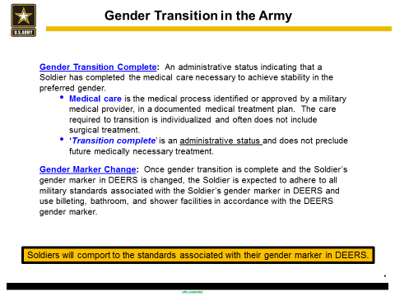
ELO: Soldiers maintain good order and discipline | 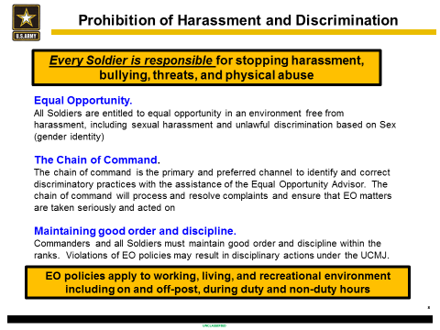

Harassment and Discrimination
- Every Soldier is responsible to stop harassment (discrimination based), bullying (power based), threats, and physical abuse
- Harassment can affect Soldiers physically and professionally
- Inappropriate jokes, attitudes, or comments that marginalize transgender people damage the command climate
- Transgender Soldier’s won’t seek they help they need in an environment that permits harassment and bullying

Respect for Personal Information and Standards of Conduct
All Soldiers are responsible for upholding and maintaining the high standards of the U.S. Military at all times and at all places. Army leaders retain the authority provided by law and DoD and Army regulations to counsel, discipline, and involuntarily separate those Service members who fail to obey established standards.

Privacy
- Maintain dignity and respect for all
- Consider both your own privacy needs and the privacy needs of others- you may encounter individuals who appear as one sex, but have the physical characteristics of the opposite sex
- Maintain personal privacy in locker rooms, showers, and living quarters
- Discuss your concerns with your chain of command
- Out of respect for the transgender Service member, personnel should not disclose someone’s gender identity without their permission, unless the disclosure is made for official use

How does a Soldier best demonstrate behavior that conveys an environment of dignity and respect?”
Social interactions and developing friendships with peers are what contribute to a positive work environment. Maintain an inclusive environment and do not gossip.
In accordance with good order and discipline, do not ask a colleague or subordinate for their personal information unless it is mission related. This includes information about a Soldier’s gender identity, sexuality, medical challenges, and/or gender transition.

ELO:  - Soldiers understand the U.S. Army policy on transgender military service has changed.  - Soldiers understand terminology associated with Army gender transition. | 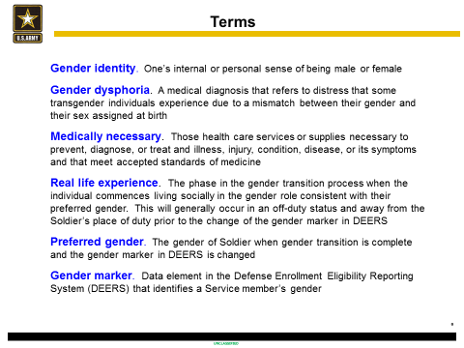
 | 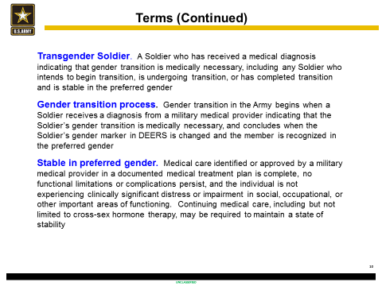

Discussion of definitions: (reference OSD Handbook)
Sex and gender are different. Sex is whether a person is male or female through their biology. Gender is the socially defined roles and characteristics of being male and female associated with that sex. There are a number of people for whom these associations do not match. This feeling may arise in childhood, adolescence or adulthood and may result in gender dysphoria.
Gender dysphoria is a medical diagnosis that refers to distress that some transgender individuals experience due to a mismatch between their gender and their sex assigned at birth. The condition can manifest in a person as strong and persistent cross-gender identification and a discomfort with their biological sex, or a sense of inappropriateness in the gender role of that sex. Transgender Soldiers may face challenges centered on their own personal situation and/or others’ unfamiliarity with gender identity issues.
The Gender Transition Process
Army Directive 2016-35 (Army Policy on Military Service of Transgender Soldiers) establishes policies and procedures for gender transition in the Army.
- Any Soldier with a diagnosis indicating that gender transition is medically necessary must ensure that his or her chain of command is informed of the diagnosis and projected schedule for medical treatment that is part of the Soldier's medical treatment plan, including an estimated date for a change in the Soldier's gender marker, and must request that the chain of command approve the timing of the medical treatment. The Soldier must notify his or her chain of command of any change to the medical treatment plan, the projected schedule for such treatment, or the estimated date for the change in the Soldier's gender marker.
- The exact procedures Soldiers, military medical providers, and commanders are to follow in relation to a Soldier's gender transition depend on the Soldier's duty status and eligibility for military medical care.
- When the Soldier is stable in his or her preferred gender, as determined or confirmed by a military medical provider, the Soldier may request approval of a change to their gender marker in DEERS. The request for a change in gender marker must be supported by a medical diagnosis from a military medical provider (or a civilian medical provider if the Soldier is ineligible for military medical care) indicating that gender transition is medically necessary; confirmation from a military medical provider that the Soldier is stable in the preferred gender; and legal documentation supporting a gender change, consisting of a certified copy of a State birth certificate, a certified copy of a court order, or a U.S. passport showing the Soldier's preferred gender.
- Within 30 days after receiving a request for a change to a Soldier's gender marker and all required documentation (within 60 days for reserve component Soldiers), the applicable approval authority will approve a change to the Soldier's gender marker in DEERS to show the Soldier's preferred gender. The approval will be in writing and state the effective date of the change to the Soldier's gender marker.
- The Commander, U.S. Army Human Resources Command, Commander, US Army Reserve Command, or the Director, Army National Guard, as applicable, will make the change in the Army personnel information systems, which in turn will update the gender marker in DEERS.
- After the gender marker in DEERS is changed to show a Soldier's preferred gender, the Soldier will be expected to adhere to Army standards applicable to the preferred gender.
- The change to the gender marker in DEERS does not preclude additional medically necessary care.

ELO:  - Soldiers understand the U.S. Army policy on transgender military service has changed.  - Soldiers understand basic process on how to initiate gender transition if necessary.  - Soldiers understand terminology associated with Army gender transition | 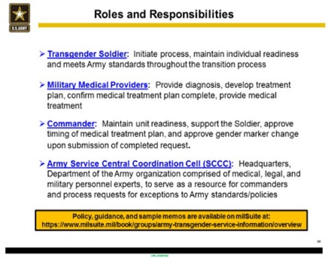
 | 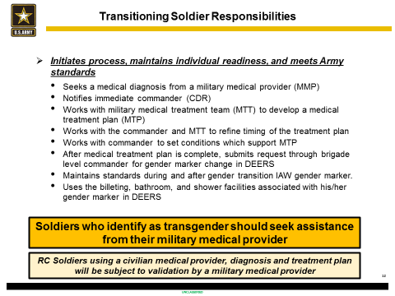

This section of instruction requires reading and discussion of the DoD, Transgender Service in the U.S. Military, an Implementation Handbook, 30 September 2016. The Handbook is guidance, not policy. The Services may implement some aspects of the DoD policy differently. Accordingly, Army policy must be reviewed prior to making decision.
- Commanders are responsible and accountable for the overall readiness of their command. Commanders are also responsible for the collective morale, welfare, good order, and discipline of their unit; for the command climate; and for ensuring that all members of the command are treated with dignity and respect.
a. Commanders should approach a Soldier undergoing gender transition in the same way they would approach a Soldier undergoing any medically necessary treatment. Commanders will continue to minimize effects to the mission and ensure continued unit readiness. Commanders will balance the needs of the individual transitioning Soldier and the needs of the command in a manner that is comparable to the actions available to the commander in addressing comparable medical circumstances unrelated to gender transition. Commanders may consider the following actions:
          - Adjusting the date on which the Soldier's gender transition, or any component of the gender transition process, will begin.
          - Advising a Soldier of the availability of options for extended leave status or participation in other voluntary absence programs during the gender transition process, in accordance with Army Regulation (AR) 600-8-10 (Leaves and Passes).
          - Processing requests for exceptions to policy (ETPs) associated with gender transition in accordance with paragraph 5 of AD 2016-35.
          - Establishing or adjusting local policies on the use of billeting, bathroom, and shower facilities subject to regulation by the military during the gender transition process, consistent with paragraphs 4b and 4c of AD 2016-35.
          - Referring the Soldier for a determination of fitness in the disability evaluation system in accordance with DoD Instruction 1332.18 (Disability Evaluation System (DES)) and AR 40-501 (Standards of Medical Fitness).
          - Taking other actions, including the initiation of administrative or other proceedings, comparable to actions that could be initiated for other Soldiers whose ability to serve is similarly affected for reasons unrelated to gender transition.
b. Soldiers must accept living and working conditions that are often austere, primitive, and characterized by little or no privacy. All Soldiers will use the billeting, bathroom, and shower facilities associated with their gender marker in DEERS. However, commanders have discretion to employ reasonable accommodations to respect the modesty or privacy interests of Soldiers, including discretion to alter billeting assignments or adjust local policies on the use of bathroom and shower facilities, in accordance with Army policy, in the interest of maintaining morale, good order, and discipline and consistent with performance of the mission. Nevertheless, no commander may order a Soldier on the basis of his or her gender identity or transitioning status to use a billeting, bathroom, or shower facility not required of other Soldiers with the same gender marker.
c. Facilities will not be designated, modified, or constructed to make transgender­ only areas. If modifications are made to accommodate the modesty or privacy concerns of a Soldier, they must be made available for all Soldiers to use. Commanders will accommodate privacy concerns using existing facilities and furnishings where possible and will modify facilities only when other options are ineffective.
d. Commanders should remain mindful of the privacy of personal or health-related information concerning the Soldiers in their command. Personal information regarding transgender Soldiers should be safeguarded to the same extent as comparable information regarding any other Soldier.
e. The Assistant Secretary of the Army (Manpower and Reserve Affairs) (ASA (M&RA)) has established a Service Central Coordination Cell composed of medical, legal, and military personnel experts to provide advice and assistance to commanders, address their inquiries, and process requests for ETPs in connection with gender transition for decision by the ASA (M&RA).

- In general, Soldiers are expected to comport with the standards of their gender marker in DEERS. In the event that a Soldier undergoing gender transition is unable to meet a particular Army standard as a result of medical treatment or other aspects of the Soldier's gender transition, the Soldier's chain of command, together with the Soldier and/or the military medical provider, should consider options (for example, adjusting the date of a physical fitness test or extended leave options) other than requesting an ETP to depart from Army standards. If submitted, a request for an ETP to depart from the standards of a Soldier's gender marker in DEERS must be processed according to the procedures outlined in this paragraph and will be evaluated on a case-by-case basis.
Command. An Inactive National Guard Soldier should submit the ETP request to the Director, Army National Guard.
  - When submitting an ETP request, the Soldier must identify the specific policy for which the Soldier is seeking an exception and explain the reason for the request. The request must be accompanied by a medical diagnosis from a military medical provider (or a civilian medical provider if the Soldier is ineligible for military medical care), an approved medical treatment plan identifying medically necessary treatment and a projected schedule for such treatment, and an estimated date for completion of the treatment pursuant to the medical treatment plan.
  - As soon as practicable, but no later than 60 days after receipt of an ETP request, the recipient of the request (as identified in paragraph 5a of AD 2016-35) must forward the request through the first general officer in the chain of command to the Service Central Coordination Cell or, if disestablished, to the relevant policy proponent in Headquarters, Department of the Army. Informed, as appropriate, by advice from a military medical provider, the recipient must provide a recommendation for action on the ETP request and an assessment of the expected effects, if any, the ETP will have on mission readiness and the good order and discipline of the unit. Commanders should include in their assessment a discussion of what other actions not requiring deviation from Army policies they considered or used and why the actions were ineffective or inadequate.
  - The ASA (M&RA) has withheld the authority to decide requests for ETPs in relation to a Soldier's gender transition.

Military Personnel Drug Abuse Testing Program
It is DoD and Army Policy that a urinalysis sample must be collected by direct observation and that, absent an exception to policy, the observer will be the same gender as the Soldier being observed (as reflected by the gender marker in DEERS).

Under DoD Instruction (DoDI) 1010.16, implementing the Military Personnel Drug Abuse Testing Program (MPDATP), "[s]pecimens are collected under the direct observation of a designated individual of the same sex as the Service member providing the specimen." Under DoDI 1300.28, implementing DoD's policy on in-service transition of transgender Service members, the Military Services "recognize a Service member's gender by the member's gender marker in the DEERS" and, "[c]oincident with that gender marker," apply all standards for MPDAPT participation, as well as "other military standards applied with consideration of the member's gender."

To the extent there was any apparent conflict or confusion between the DoDI 1010.16 requirement of "same sex" observers and the DoDI 1300.28 requirement that the Services apply the MPDAPT coincident with a Service member's gender marker in DEERS, the Office of the Under Secretary of Defense (Personnel and Readiness) (USD) (P&R) addressed this issue in a memorandum, dated 22 Sep 16, clarifying that "Service members providing a urinalysis specimen are observed by an individual with the same gender marker in DEERS." In other words, for the purposes of interpreting these two Instructions in conjunction with one another, "sex" in DoDI 1010.16 refers to the same thing as "gender" in DoDI 1300.28. This clarification is consistent with DoDI 1300.28 and Army Directive 2016-35, as well as the DoD Handbook and other guidance provided by OSD and Army, all of which state that MPDATP standards will be applied coincident with the gender marker in DEERS.

The ASA(M&RA) currently is the approval authority for all ETPs related to transgender service. Accordingly, under current Army policy, the observer under the MPDATP must have the same gender marker as the Soldier being observed, unless there is an ETP approved by the ASA(M&RA).

Vignettes.
The fictional cases provided in the associated training slide deck, illustrate situations that Soldiers may encounter. The delineation of responsibilities in each scenario is intended only to provide a general discussion. The vignettes are not all inclusive, nor are they directive in nature. All Soldiers should consult with their chain of command, SCCC, DoD and Army policy and guidance before determining the best course(s) of action. Commanders are reminded of their responsibility to ensure good order and discipline throughout their entire unit. Instructors should use the vignettes as a touchpoint for group discussion.

